COGNETIX GLOBAL TECHNOLOGY LLP
Cybersecurity Internship – Level 1 Project 2
Firewall Configuration & System Hardening

Prepared by: Ishwari Ajaykumar Patil
Intern ID: CT/CS/X156
Remote Cybersecurity
Internship Date: 30 June 2026

- Introduction
Firewall configuration and system hardening are essential cybersecurity practices used to protect computer systems from unauthorized access, malware, and network-based attacks. A firewall acts as a security barrier between a trusted internal system and external networks by filtering incoming and outgoing traffic based on predefined security rules. System hardening further improves security by disabling unnecessary services, enforcing security policies, and reducing potential vulnerabilities. In this project, Windows Defender Firewall was configured to allow secure network ports and block insecure ports, while additional hardening measures were applied to strengthen the overall security of the Windows system.

- Objective

The objective of this project is to configure Windows Defender Firewall by allowing only essential network ports and blocking insecure ports. Additionally, basic system hardening techniques such as disabling the Guest account, verifying Windows updates, documenting password policies, and testing firewall configurations were implemented to improve system security and minimize the risk of unauthorized access.

- Tools Used

The following tools were used during this project:

- Windows 11 Operating System
- Windows Defender Firewall with Advanced Security
- Command Prompt (CMD)
- Windows PowerShell
- Windows Update
- Netsh Firewall Utility
- Netstat Utility
- Test-NetConnection (PowerShell)

- Methodology

Step 1 – Enable Windows Defender Firewall

Procedure
Open Control Panel → System and Security → Windows Defender Firewall and verify that the firewall is enabled for all network profiles (Private and Public).

Purpose
To ensure that the Windows Defender Firewall is active and providing protection against unauthorized network access.

Result
The firewall was successfully enabled and active for all available network profiles.

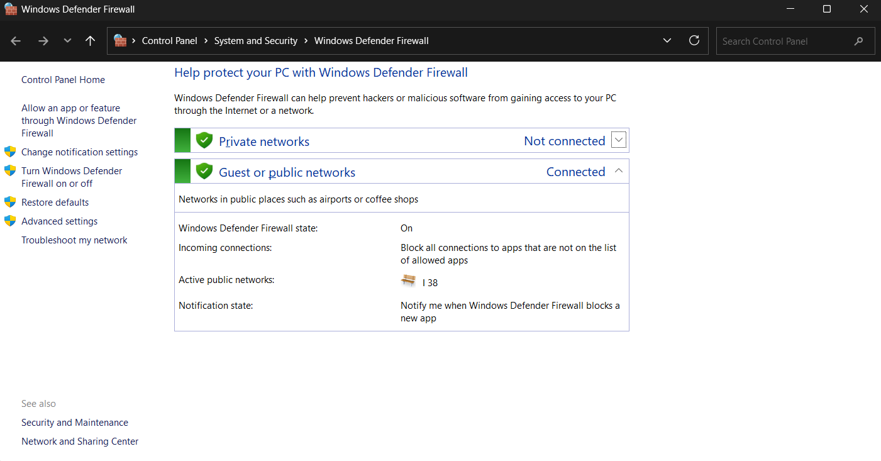

Step 2 – Open Windows Defender Firewall with Advanced Security

Procedure
Open Windows Defender Firewall with Advanced Security from the Start menu or by selecting Advanced Settings from the Windows Defender Firewall window.

Purpose
To access advanced firewall settings for creating and managing inbound firewall rules.

Result
The Windows Defender Firewall with Advanced Security console was successfully opened.

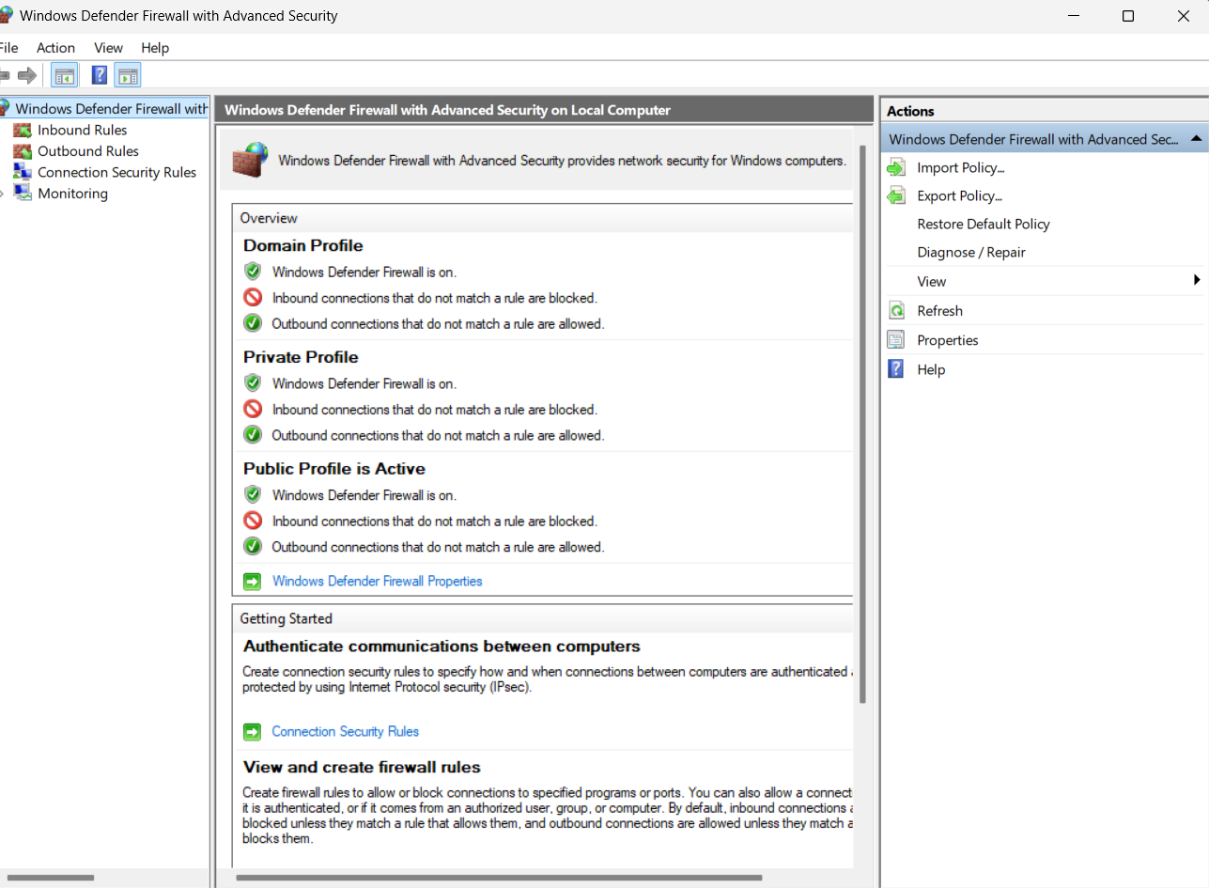

Step 3 – Create Firewall Rules to Allow Safe Ports

Procedure
Created inbound firewall rules to allow the following TCP ports:
- Port 22 (SSH)
- Port 80 (HTTP)
- Port 443 (HTTPS)
Each rule was configured with the Allow the connection option and applied to Domain, Private, and Public profiles.

Purpose
To permit secure and commonly used network services while maintaining firewall protection.

Result
Firewall rules allowing inbound traffic on ports 22, 80, and 443 were successfully created.

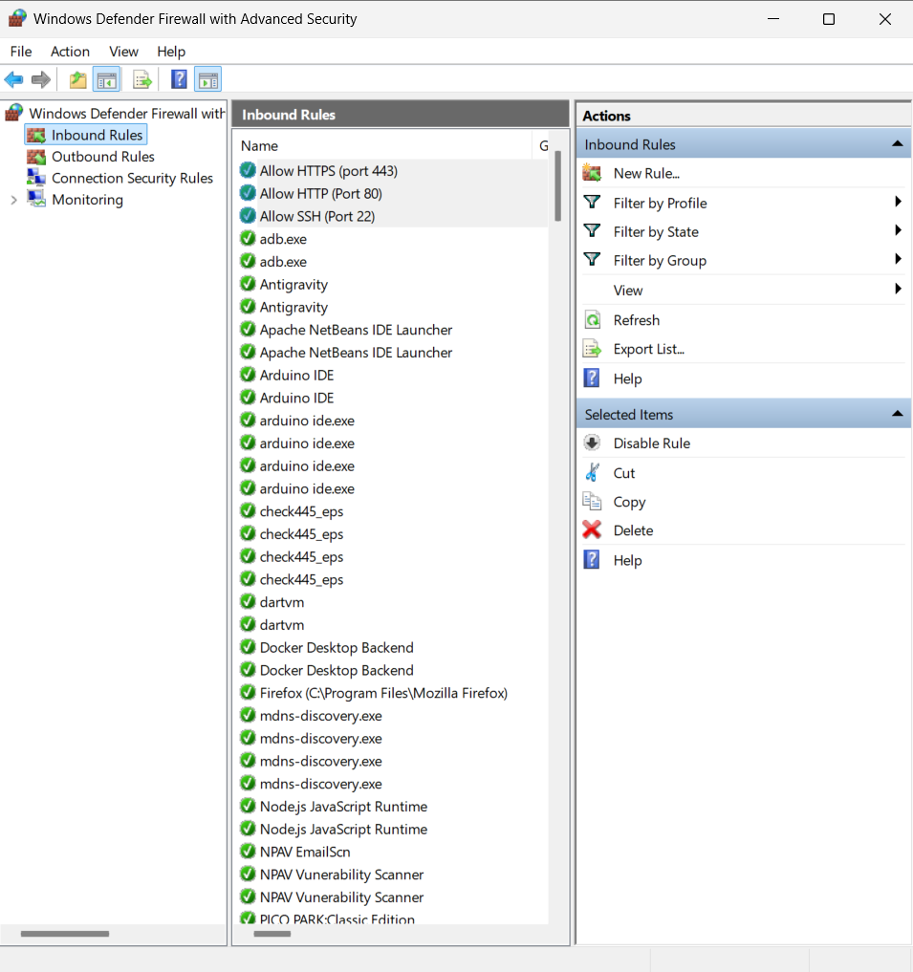

Step 4 – Create Firewall Rules to Block Unsafe Ports

Procedure
Created inbound firewall rules to block the following TCP ports:
- Port 21 (FTP)
- Port 23 (Telnet)
Each rule was configured with the Block the connection option and applied to all network profiles.

Purpose
To prevent access through insecure protocols that transmit data without encryption.

Result
Firewall rules blocking inbound traffic on ports 21 and 23 were successfully created.

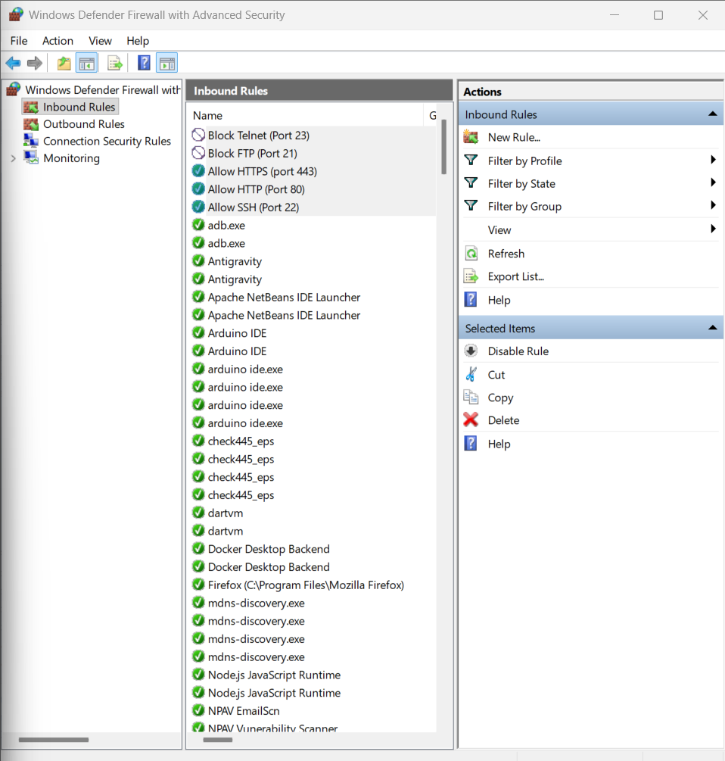

Step 5 – Verify Firewall Rules

Command
netsh advfirewall firewall show rule name="Allow SSH (Port 22)"
netsh advfirewall firewall show rule name="Allow HTTP (Port 80)"
netsh advfirewall firewall show rule name="Allow HTTPS (Port 443)"
netsh advfirewall firewall show rule name="Block FTP (Port 21)"
netsh advfirewall firewall show rule name="Block Telnet (Port 23)"

Purpose
To verify that the firewall rules were successfully created with the correct port numbers and actions.

Result
The output confirmed that all firewall rules were enabled and correctly configured with their respective Allow and Block actions.

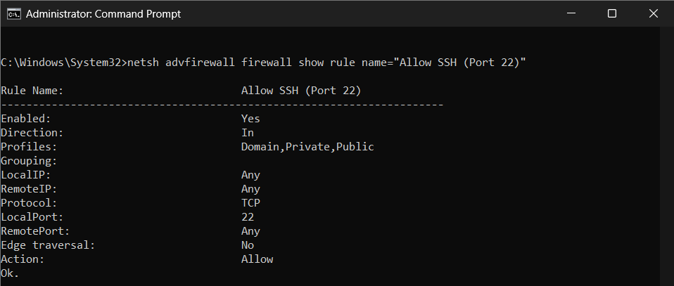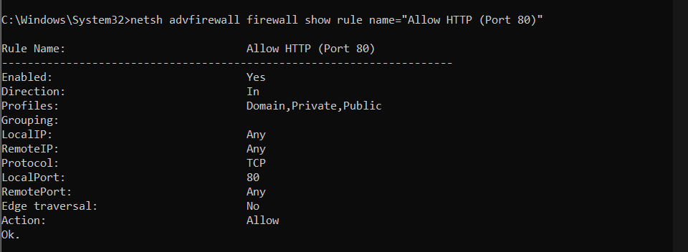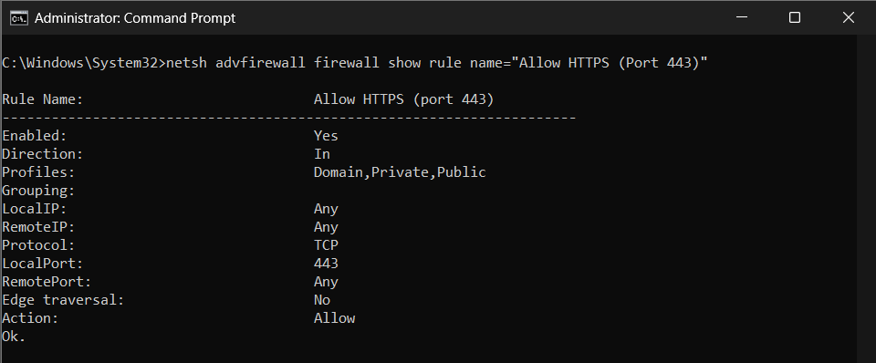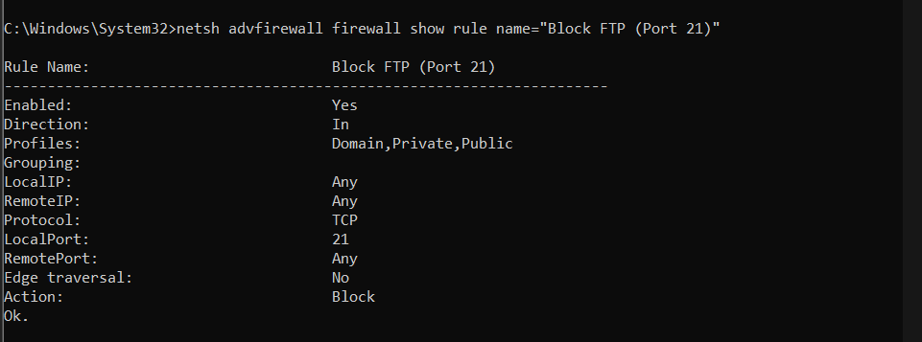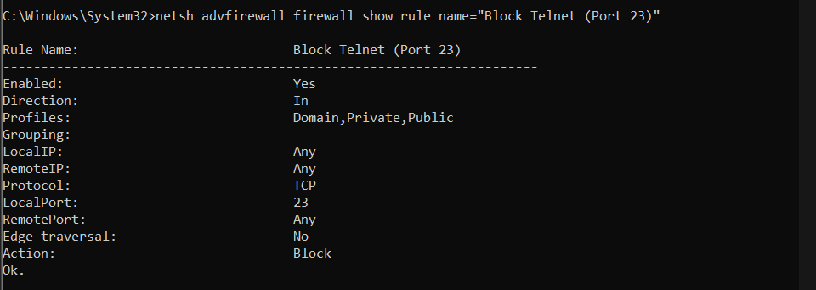

Step 6 – Disable the Guest Account

Command
net user Guest /active:no

Verification Command
net user Guest

Purpose
To disable the built-in Guest account and reduce the risk of unauthorized system access.

Result
The Guest account was successfully disabled, and the account status displayed Account active : No.

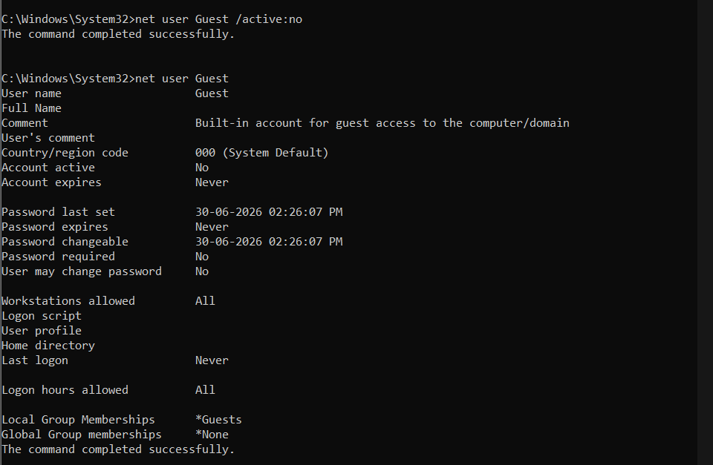

Step 7 – Verify Windows Update

Procedure
Open Settings → Windows Update and check the update status.

Purpose
To ensure that the operating system is configured to receive the latest security patches and updates.

Result
The Windows Update settings confirmed that the system was checking for updates and security updates were enabled.

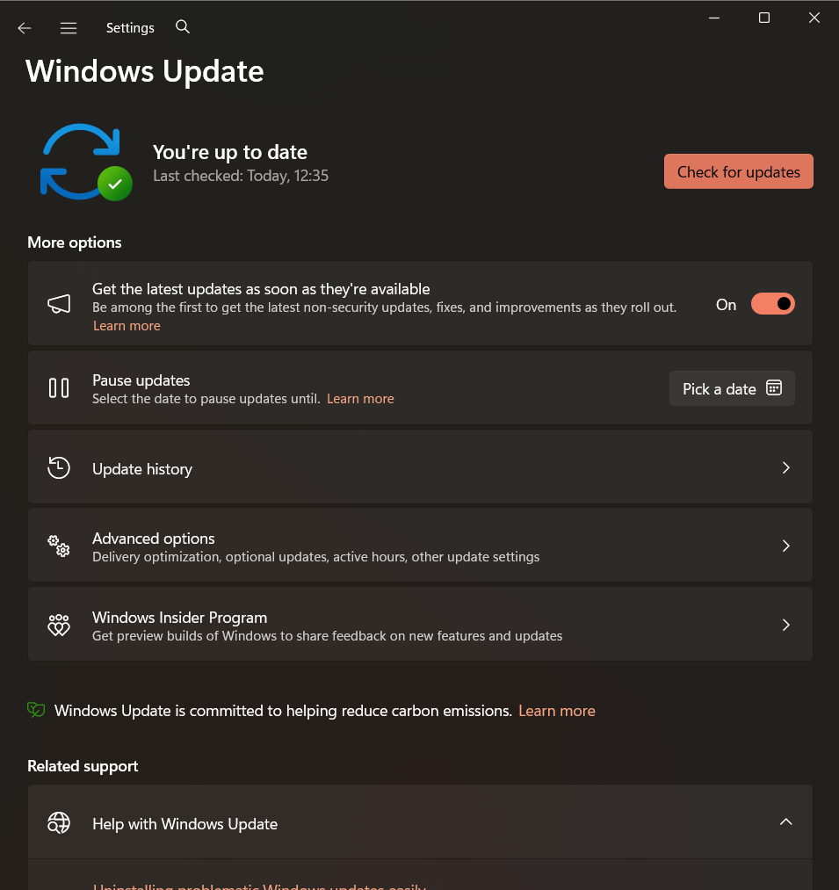

Step 8 – Review Password Policy

Procedure
Attempted to open the Local Security Policy Editor using:
secpol.msc

Purpose
To configure password security settings such as minimum password length, password complexity, and password aging.

Result
Since the project was performed on Windows Home Edition, the Local Security Policy Editor was unavailable. Therefore, the recommended password policy settings were documented instead.

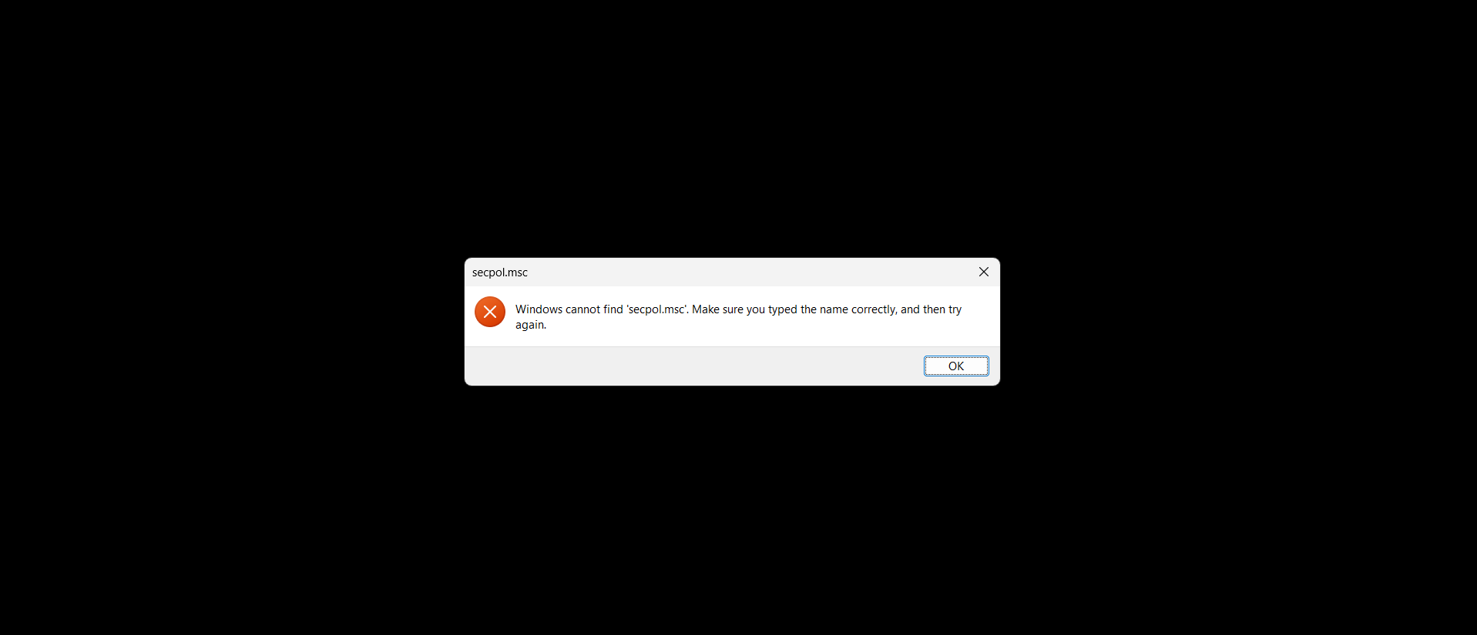

Step 9 – Check Listening Ports

Command
netstat -an

Purpose
To display active TCP and UDP connections and identify ports currently in the LISTENING state.

Result
The command displayed active network connections. Ports 21, 22, 23, 80, and 443 were not listed because no corresponding services were running on the system.

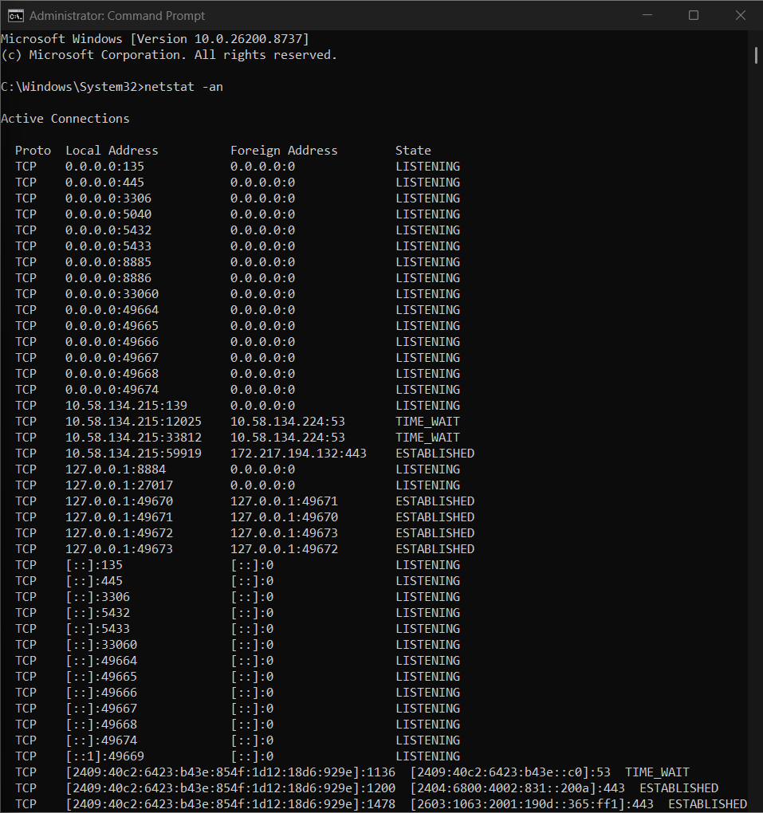
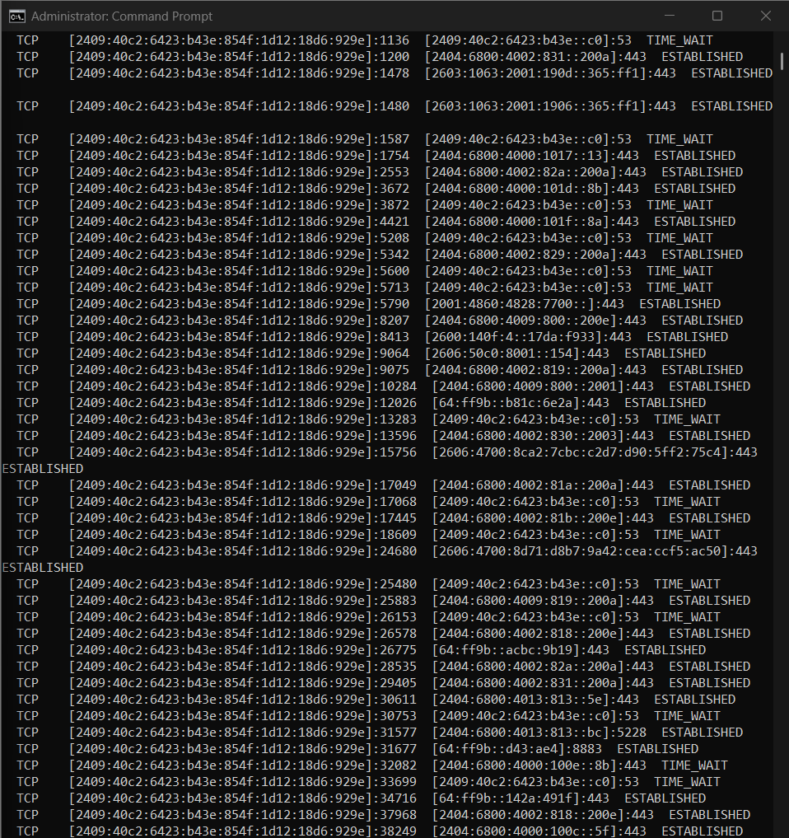

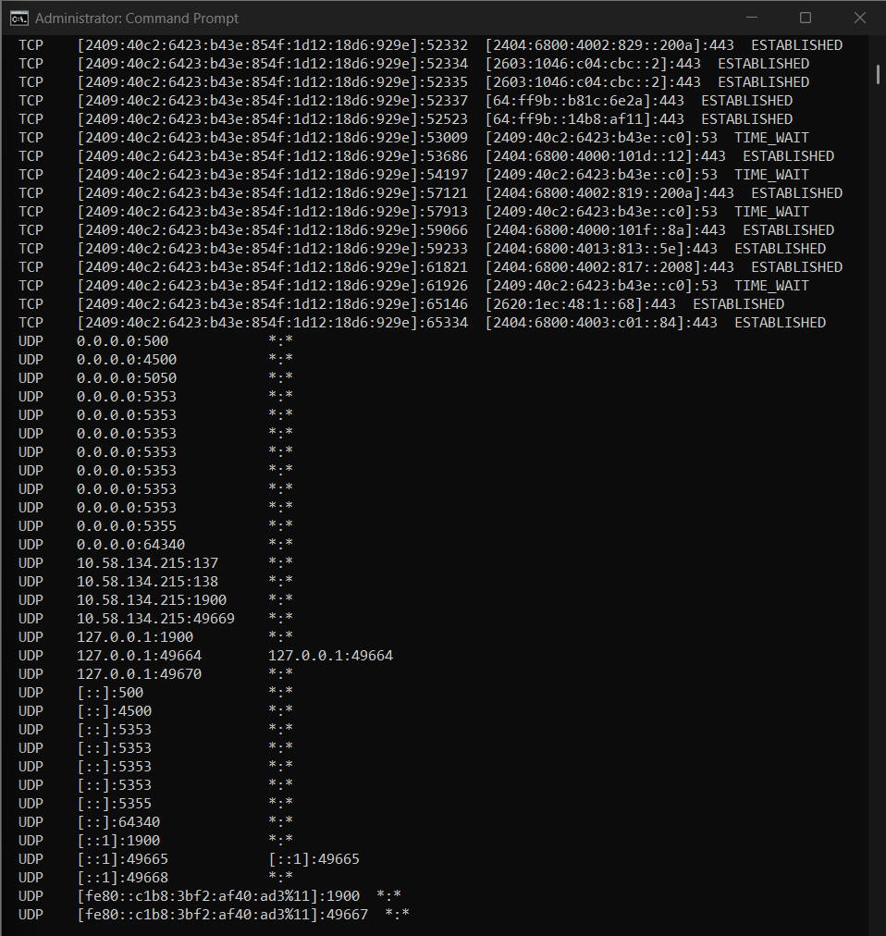

Step 10 – Test Firewall Rules

Command (Windows PowerShell)
Test-NetConnection localhost -Port 21
Test-NetConnection localhost -Port 23
Test-NetConnection localhost -Port 22
Test-NetConnection localhost -Port 80
Test-NetConnection localhost -Port 443
Purpose
To test connectivity to the configured ports and verify the effectiveness of the firewall configuration.

Result
All tests returned TcpTestSucceeded : False, indicating that no services were listening on the tested ports. This behavior is expected and confirms that unnecessary network services were not exposed.

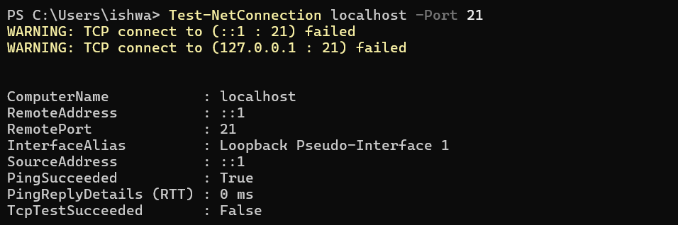
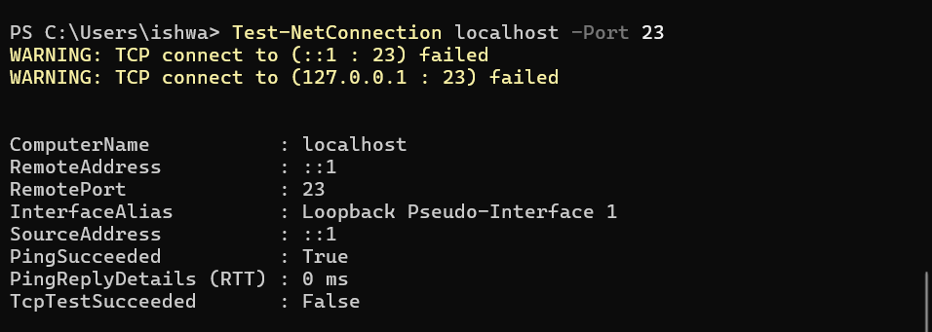
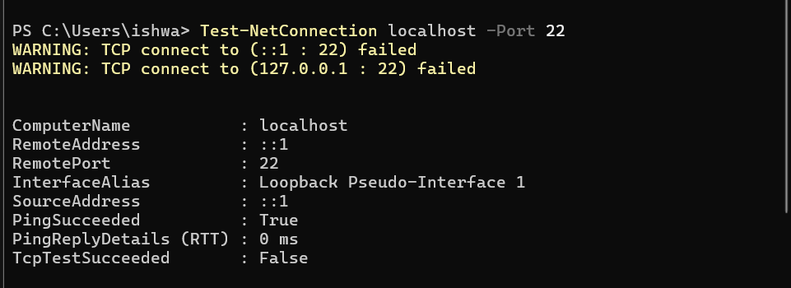
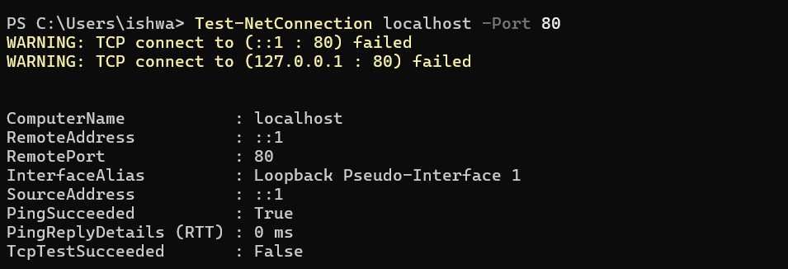
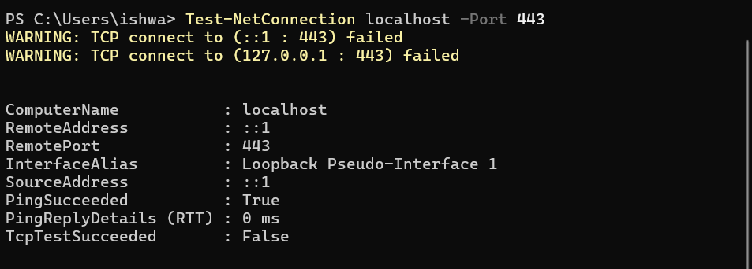

- Firewall Configuration Policy

Policy | Configuration
Firewall | Enabled
Allowed Ports | 22, 80, 443
Blocked Ports | 21, 23
Network Profiles | Domain, Private, Public

- Port Allow/ Deny Matrix
Port | Service | Action | Reason
22 | SSH | Allow | Secure remote administration
80 | HTTP | Allow | Web traffic
443 | HTTPS | Allow | Secure web traffic
21 | FTP | Block | Unencrypted protocol
23 | Telnet | Block | Unencrypted remote access

- Results

The firewall configuration and system hardening tasks were successfully completed. Windows Defender Firewall was enabled on all network profiles, and inbound rules were created to allow ports 22, 80, and 443, while ports 21 and 23 were blocked. The firewall rules were successfully verified using the netsh advfirewall command. The Guest account was disabled, Windows Update settings were verified, and network ports were examined using netstat. Firewall testing using Test-NetConnection confirmed that no unnecessary services were listening on the configured ports, indicating a secure system configuration.

- Security Analysis

Proper firewall configuration significantly reduces the attack surface of a computer system by permitting only authorized network traffic while blocking insecure or unnecessary connections. Allowing only essential ports such as SSH, HTTP, and HTTPS supports legitimate communication, whereas blocking insecure protocols like FTP and Telnet helps prevent unauthorized access and credential theft. Disabling the Guest account further reduces unauthorized access risks. Regular system updates ensure protection against newly discovered vulnerabilities, while documenting password policies promotes stronger authentication practices. Together, these measures improve the overall security posture of the system.

- Conclusion

The firewall configuration and system hardening project was successfully completed using Windows Defender Firewall and built-in Windows security tools. Firewall rules were configured to allow secure services and block insecure services, and additional hardening measures such as disabling the Guest account, verifying Windows updates, documenting password policies, and testing firewall functionality were performed. The project demonstrated the importance of firewall management and system hardening in protecting systems against network-based threats and improving overall cybersecurity.

